
North Campus
Assignment 3

Subject | DATABASE MANAGEMENT SYSTEMS | Program | BS(CS)
Faculty | Faraz Abdul Basit | Time Allowed
CLO, GA | CLO3  GA3  C4 – Analyze | Maximum Marks
Efficient data retrieval is a critical requirement of database systems. Indexes play a vital role in improving query performance by optimizing access paths to data. In this assignment, you are required to analyze your project database schema and apply appropriate indexing strategies.

Assignment Tasks
- Analyze the database schema of your project and identify tables and columns that are frequently used in:
  - Search conditions
  - Join operations
  - Sorting (ORDER BY)
  - Grouping (GROUP BY)
- Based on your analysis, determine where a clustered index is necessary and justify your choice with respect to data access patterns and table structure.
- Generate appropriate non-clustered indexes on selected columns where indexing is required to optimize query performance.
  - Consider columns used in WHERE, JOIN, and ORDER BY clauses.
- Demonstrate the use of the created clustered and non-clustered indexes by executing representative SQL queries from your project and analyzing how indexing improves data retrieval.
- Justify why certain columns should not be indexed, considering factors such as data duplication, frequent updates, and storage overhead.

Submission Guidelines
- Submit SQL scripts for:
  - Index creation
  - Sample queries used for testing
- Clearly mention which index is clustered and which is non-clustered
- Provide brief explanations supporting your indexing decisions
- Use proper SQL formatting and naming conventions

NONCLUSTERED INDEX
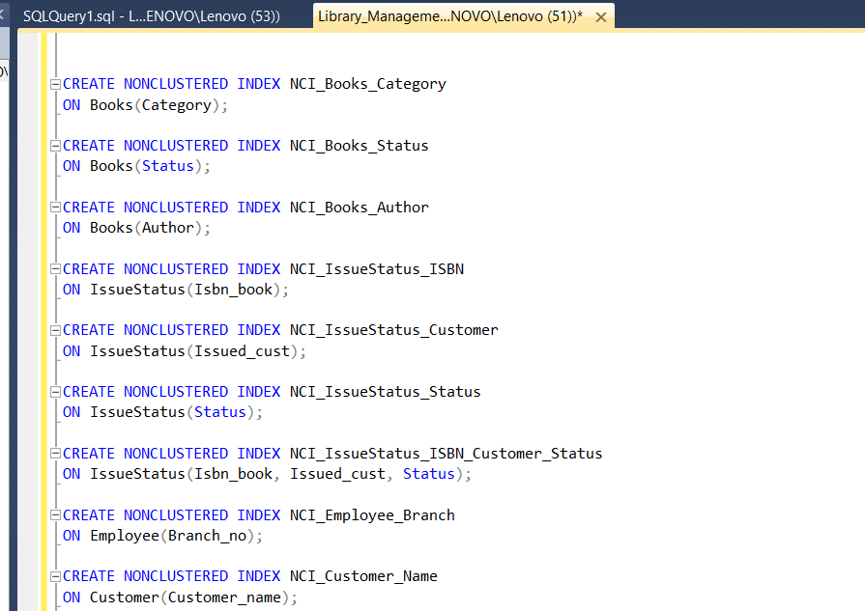

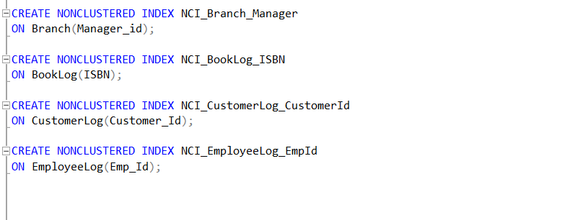
CREATE NONCLUSTERED INDEX NCI_Books_Category
ON Books(Category);

CREATE NONCLUSTERED INDEX NCI_Books_Status
ON Books(Status);

CREATE NONCLUSTERED INDEX NCI_Books_Author
ON Books(Author);

CREATE NONCLUSTERED INDEX NCI_IssueStatus_ISBN
ON IssueStatus(Isbn_book);

CREATE NONCLUSTERED INDEX NCI_IssueStatus_Customer
ON IssueStatus(Issued_cust);

CREATE NONCLUSTERED INDEX NCI_IssueStatus_Status
ON IssueStatus(Status);

CREATE NONCLUSTERED INDEX NCI_IssueStatus_ISBN_Customer_Status
ON IssueStatus(Isbn_book, Issued_cust, Status);

CREATE NONCLUSTERED INDEX NCI_Employee_Branch
ON Employee(Branch_no);

CREATE NONCLUSTERED INDEX NCI_Customer_Name
ON Customer(Customer_name);

CREATE NONCLUSTERED INDEX NCI_Branch_Manager
ON Branch(Manager_id);

CREATE NONCLUSTERED INDEX NCI_BookLog_ISBN
ON BookLog(ISBN);

CREATE NONCLUSTERED INDEX NCI_CustomerLog_CustomerId
ON CustomerLog(Customer_Id);

CREATE NONCLUSTERED INDEX NCI_EmployeeLog_EmpId
ON EmployeeLog(Emp_Id);

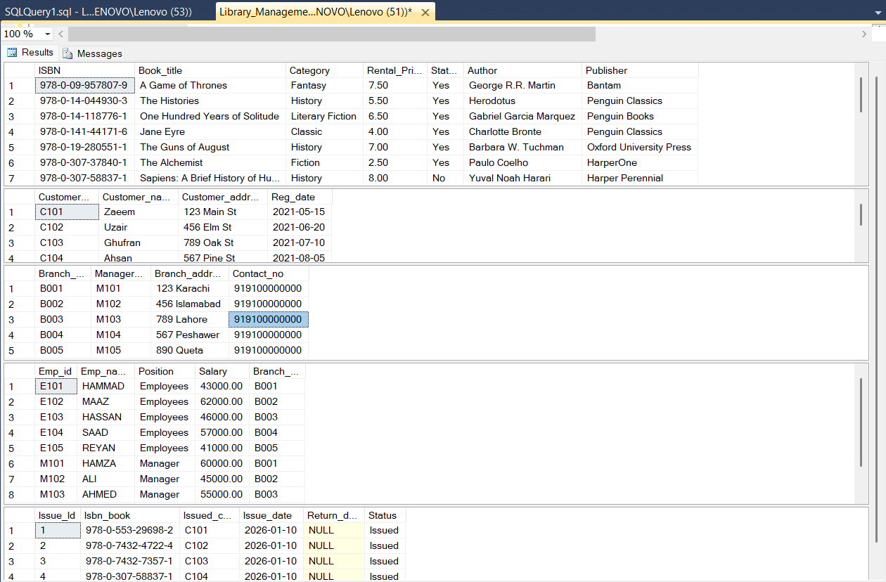

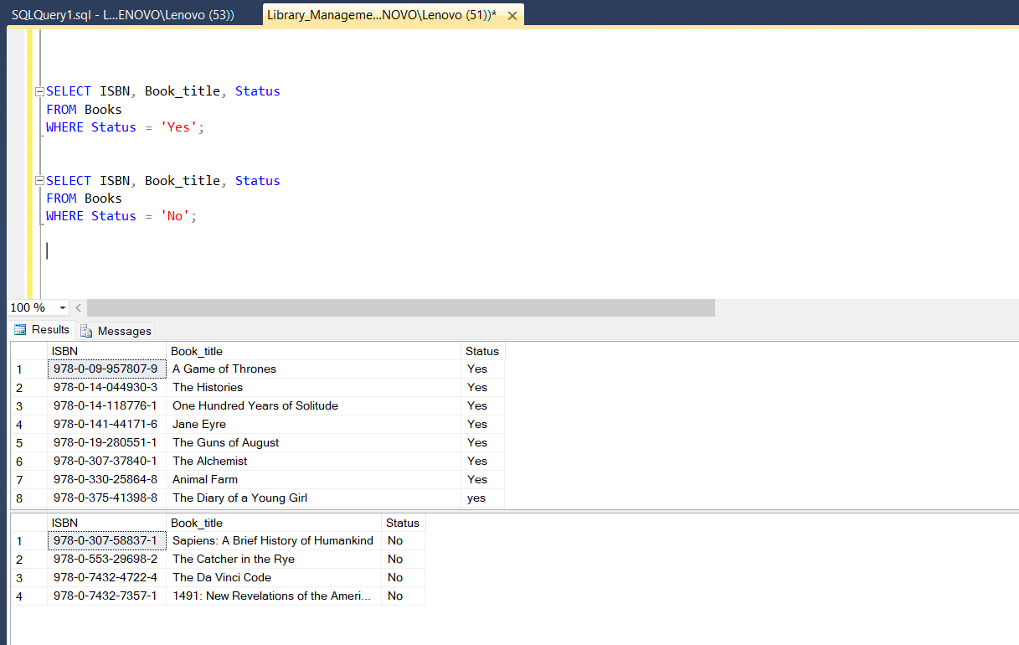

CLUSTERED INDEX
